GROCERY SALES DATA ANALYSIS
A Business Intelligence & Sales Analytics Project Using Power BI

Spiral Binding Project Report

PROJECT DETAILS | DETAILS
Student Name | IDRIS BOHRA
Roll / Enrolment No. | BV25-SD01
Department | SD
College / Institute | THAKUR COLLEGE OF ENGINEERING &  TECHNOLOGY
Academic Year | 2026–2027

This is to certify that Idris Bohra of BVOCSD has successfully completed the project titled “Grocery Sales Data Analysis: A Business Intelligence & Sales Analytics Project Using Power BI” under my guidance during the academic year 2026–2027.
The work presented in this report is submitted as part of the academic requirements of the program and demonstrates the application of data preparation, data modelling, DAX calculations, visualization and business analysis using Microsoft Power BI.

Place | Date | Signature
____________ | ____________ | ____________

DECLARATION
I hereby declare that the project report entitled “Grocery Sales Data Analysis: A Business Intelligence & Sales Analytics Project Using Power BI” is my original academic work prepared for the purpose of demonstrating practical skills in business intelligence, data analysis and dashboard development. The analysis, calculations, dashboard design and interpretation presented in this report have been prepared for this project.
Where external datasets, software documentation or learning resources have been used, they have been acknowledged in the references section. The project does not claim profitability analysis because the supplied sales dataset does not contain product cost or operating-cost fields.

Student Signature: __________________________
Name: Idris Bohra
Date: __________________

ABSTRACT
This project presents a Business Intelligence solution for analysing grocery retail sales using Microsoft Power BI. The primary objective is to transform raw transactional sales data into meaningful business insights through interactive dashboards, analytical measures and visual reporting. The project focuses on evaluating overall sales performance, product demand, store and employee performance, customer transactions, discounts, product returns and future sales trends to support effective business decision-making.
The dataset contains grocery sales transactions along with related information about products, stores, employees, payment methods and transaction dates. Important attributes include product categories, product names, quantities sold, selling prices, discount percentages, transaction values and customer ratings. The project applies data cleaning and transformation using Power Query, relational data modelling, calculated columns and Data Analysis Expressions (DAX). A dedicated Date table supports time-based calculations, while relationships between the Sales table and supporting dimension tables enable consistent filtering and analysis.
The final Power BI solution consists of six interactive analytical dashboards: Executive Sales Dashboard, Product Analysis, Store & Employee Analysis, Sales & Discount Analysis, Customer & Transaction Analysis, and Future Sales Predictions. These dashboards use KPI cards, column charts, line charts, donut charts, matrices, slicers, decomposition trees, key influencers and forecasting visuals to present business information in an understandable and interactive format.
The analysis includes key performance indicators such as Total Sales, Total Transactions, Total Quantity Sold, Average Transaction Value, Total Discount, Return Rate and Average Customer Rating. Additional DAX measures, including Year-to-Date Sales, Previous Year Sales and Year-over-Year Growth, support performance comparisons across different periods. The forecasting dashboard also presents estimated future sales trends based on historical data.
The project demonstrates how Business Intelligence techniques can be applied to identify high-performing products and stores, understand customer purchasing behaviour, evaluate discount and return patterns, and support sales planning. The analysis focuses on measurable sales performance rather than unsupported profitability conclusions, since product cost and operating expense information is not available in the dataset.
Overall, the project provides practical experience in data preparation, relationship modelling, DAX calculations, dashboard development, interactive visual analytics and forecasting. The resulting Power BI report offers a structured approach to grocery sales monitoring and provides useful insights for data-driven retail management.
Keywords: Business Intelligence, Microsoft Power BI, Grocery Sales Analysis, Power Query, DAX, Data Modelling, Sales Dashboard, KPI, Data Visualization, Forecasting, Retail Analytics.

LIST OF FIGURES
Figure 4.3: Grocery Sales Data Model and Table Relationships
Figure 6.1: Executive Sales Dashboard
Figure 6.2: Product Analysis Dashboard
Figure 6.3: Store and Employee Analysis Dashboard
Figure 6.4: Sales and Discount Analysis Dashboard
Figure 6.5: Customer and Transaction Analysis Dashboard
Figure 6.6: Future Sales Predictions Dashboard

LIST OF TABLES
Table 2.2: Dataset Tables and Their Descriptions
Table 5.2: Key Performance Indicators and Their Purposes
Table 9.2: Testing Activities and Validation Procedures

CHAPTER 1 — INTRODUCTION

1.1 Background
Business Intelligence (BI) involves collecting, preparing, analysing and presenting data to support informed business decisions. In retail businesses, sales transactions provide valuable information about product demand, revenue, discounts, customer transactions and store performance. However, raw data requires systematic analysis to identify meaningful patterns and trends.
Microsoft Power BI provides tools for data transformation, data modelling, DAX calculations and interactive visualization. It enables users to convert transactional records into dashboards that support performance monitoring and business analysis.
This project applies Business Intelligence techniques to grocery sales data using Microsoft Power BI. It examines sales performance across products, stores, employees, payment methods and time periods through an organized data model and interactive dashboards.

1.2 Problem Statement
Raw grocery sales records can be difficult to analyse manually, particularly when information is distributed across multiple related tables. Without a structured analytical report, comparing sales performance, identifying high-performing products and stores, and understanding discount and return patterns can be challenging.
The project addresses this problem by developing an interactive Power BI report that organizes sales information into meaningful indicators and visualizations. It provides a consolidated view of historical performance to support data-driven analysis.

1.3 Project Aim
To develop an interactive Business Intelligence report using Microsoft Power BI that analyses grocery sales data and presents meaningful sales trends, performance indicators and business insights.

1.4 Project Objectives
The main objectives of the Grocery Sales Data Analysis project are:
- To clean and transform grocery sales data using Power Query.
- To establish relationships between sales data and supporting tables.
- To create calculated columns and DAX measures for key performance indicators.
- To analyse sales performance across products, stores, employees and time periods.
- To evaluate discounts, product returns, payment methods and customer ratings.
- To develop interactive dashboards for effective data visualization.
- To examine historical sales trends and generate future sales forecasts.
- To present meaningful insights that support data-driven retail decisions.

1.5 Scope of the Project
The project covers the preparation, modelling and analysis of grocery sales data using Microsoft Power BI. It includes the development of six dashboards: Executive Sales Dashboard, Product Analysis, Store & Employee Analysis, Sales & Discount Analysis, Customer & Transaction Analysis, and Future Sales Predictions.
The analysis focuses on sales indicators, transaction activity, product demand, store performance, discounts, returns, customer ratings and historical sales trends. Interactive charts, KPI cards and filters are used to make the report easier to explore.
The project is limited to the information available in the supplied dataset. Since product costs and operating expenses are not available, the report does not calculate profit margins or overall business profitability. The findings and forecasts are based on the available historical data.

CHAPTER 2 — DATASET & BUSINESS REQUIREMENTS

2.1 Dataset Overview
The project uses grocery sales data to analyse retail transactions and identify patterns in sales performance. The dataset includes transaction-level information and related details about products, stores, employees, customers and payment methods.
Important attributes include product names and categories, quantities sold, selling prices, discount percentages, transaction values, transaction dates and customer ratings. These fields support the calculation of key performance indicators and the development of interactive dashboards in Microsoft Power BI.

2.2 Dataset Tables
The data is organized into a sales table and related supporting tables. These tables are connected through relationships in the Power BI data model to enable analysis across different business dimensions.
Data Area | Purpose
Sales | Records sales activity and transaction values
Product | Supports analysis by product name and category
Store | Enables comparison of sales across store locations
Employee | Supports employee-level sales analysis
Customer | Provides customer-related information where available
Date | Enables analysis by day, month, year and time period
Payment | Supports analysis of transaction payment types

Table 2.2: Dataset Tables and Their Descriptions

2.3 Business Requirements
The project addresses the following analytical requirements:
- Monitor overall sales performance using KPI cards.
- Identify products and categories contributing to sales.
- Compare sales performance across stores and employees.
- Examine discount patterns and product returns.
- Analyse transaction activity, payment methods and customer ratings.
- Compare sales across different time periods.
- Explore historical trends and forecast future sales.
- Present the results through interactive dashboards and filters.
These requirements guide the selection of DAX measures, visualizations and dashboard layouts used in the project.

CHAPTER 3 — TOOLS AND TECHNOLOGIES

3.1 Microsoft Power BI
Microsoft Power BI is the primary Business Intelligence tool used in this project. It enables the import, transformation, modelling and visualization of grocery sales data. Its interactive dashboards help present key performance indicators and sales trends in a clear and structured format.

3.2 Power Query
Power Query is used to prepare the dataset before analysis. It supports data cleaning, column formatting, handling missing or inconsistent values, and transforming data into a suitable structure for reporting.

3.3 Data Analysis Expressions (DAX)
DAX is used to create calculated columns and measures for analysing sales performance. Measures such as Total Sales, Total Transactions, Total Quantity Sold, Average Transaction Value and Year-over-Year Growth support the calculation of important business indicators.

3.4 Data Modelling
Data modelling organizes the sales table and related supporting tables into a connected structure. Appropriate relationships allow the dashboards to analyse sales by product, store, employee and date while maintaining consistent filtering across visuals.

3.5 Data Visualization
Power BI visualizations present analytical results using KPI cards, column charts, line charts, donut charts, matrices and other relevant visuals. Slicers and filters allow users to interact with the report and examine specific categories, stores and periods.

3.6 Forecasting and Analytical Features
Power BI forecasting and analytical features are used to explore potential future sales trends and identify factors associated with sales outcomes. These features help extend the report beyond historical summaries and support further investigation of the available data.

CHAPTER 4 — DATA PREPARATION AND DATA MODEL

4.1 Data Preparation Using Power Query
Data preparation is an important step in developing a reliable Business Intelligence report. Before creating visualizations, the grocery sales data must be reviewed, cleaned and transformed into a suitable format for analysis.
Microsoft Power Query is used to perform the required data preparation activities. These activities help improve data consistency and ensure that fields are suitable for calculations, relationships and visualizations.
The main data preparation activities include:
- Data Type Correction: Assigning appropriate data types to dates, quantities, prices, discounts and other numerical fields.
- Column Review: Checking column names and removing unnecessary fields where appropriate.
- Missing Value Handling: Identifying blank or missing values and handling them according to the requirements of the analysis.
- Duplicate Checking: Identifying duplicate records and verifying whether they represent genuine transactions or unwanted repetitions.
- Data Consistency: Checking product names, categories and other descriptive fields for inconsistent entries.
- Data Transformation: Preparing columns in a consistent format for analysis and reporting.
- Validation: Reviewing the transformed data to ensure that it remains suitable for calculations and dashboard development.
These steps help establish a consistent foundation for the subsequent data modelling and DAX calculations.

4.2 Data Quality and Validation
After transformation, the data should be checked for appropriate data types, valid numerical values and consistency across related tables. Sales values, quantities, discounts and transaction dates must be suitable for the intended calculations.
The prepared data is then loaded into Power BI for relationship modelling and dashboard development.

CHAPTER 4 — DATA PREPARATION AND DATA MODEL

4.3 Data Model and Table Relationships
The data model organizes the grocery sales data and its related tables into a connected structure in Microsoft Power BI. Relationships between tables allow information to be analysed across different business dimensions, including products, stores, employees and transaction dates.
The relationship model is designed to support consistent filtering, accurate calculations and interactive dashboard analysis. The Sales table acts as the central table for transaction analysis, while related tables provide additional descriptive information.
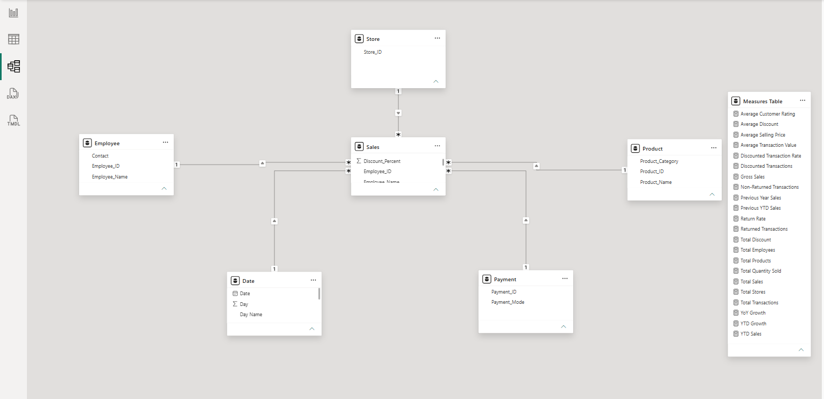
Figure 4.3: Grocery Sales Data Model and Table Relationships

4.4 Importance of the Data Model
A properly organized data model provides the following benefits:
- Connects sales transactions with relevant supporting information.
- Enables analysis by product, store, employee and date.
- Supports DAX measures and time-based calculations.
- Improves interaction between dashboard visuals and slicers.
- Reduces inconsistencies during filtering and reporting.
The model view presents the table structure and relationships implemented in Power BI.

CHAPTER 5 — DAX MEASURES

5.1 Introduction to DAX
Data Analysis Expressions (DAX) is a formula language used in Microsoft Power BI to create measures and calculated columns. In this project, DAX is used to calculate key performance indicators and analyse grocery sales data through interactive dashboards.

5.2 Key Performance Indicators
The following measures support the analysis of sales performance:

Measure | Purpose
Total Sales | Calculates the total sales value
Total Transactions | Counts sales transactions
Total Quantity Sold | Calculates the total quantity sold
Average Transaction Value | Measures the average value per transaction
Total Discount | Evaluates the total discount value
Return Rate | Measures the proportion of returned transactions or items, according to the implemented definition
Average Customer Rating | Calculates the average recorded customer rating
Year-to-Date Sales | Calculates sales from the beginning of the year to the selected date
Previous Year Sales | Provides sales for the comparable previous-year period
Year-over-Year Growth | Measures the percentage change in sales compared with the previous year
Table 5.2: Key Performance Indicators and Their Purposes

5.3 Role of DAX Measures
DAX measures enable dynamic calculations that respond to report filters and slicers. They help users compare sales performance across products, stores, employees and time periods.
Time-based measures support historical comparisons, while transaction and customer-related measures provide additional information about purchasing activity and customer experience.
The measures are used in KPI cards, charts, tables and other dashboard visuals to present meaningful analytical results.

5.4 Implementation
The measures are created in Power BI using DAX formulas and validated against the available dataset. Their results are then used throughout the report to maintain consistency in calculations and performance analysis.

CHAPTER 6 — DASHBOARD DEVELOPMENT

6.1 Executive Sales Dashboard
The Executive Sales Dashboard provides a consolidated overview of grocery sales performance. It presents key performance indicators and visual summaries to help users understand the overall performance of the business.
The dashboard includes KPI cards for important measures such as Total Sales, Total Transactions, Total Quantity Sold and Average Transaction Value. These indicators provide a quick summary of sales activity.
Charts and interactive filters allow users to explore sales performance across available time periods and business categories. The dashboard serves as the main reporting page, offering an overview before users move to more detailed analyses.
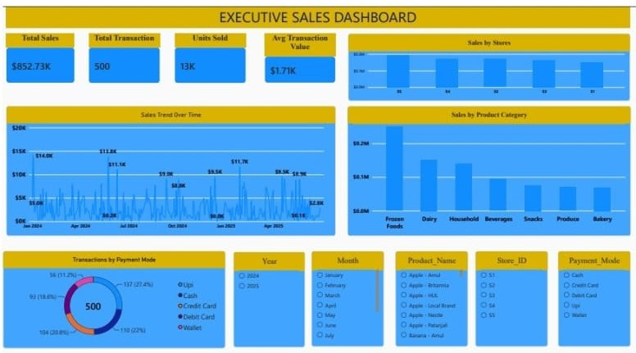
Figure 6.1: Executive Sales Dashboard

Analytical Purpose
- Monitor overall sales performance.
- Review key sales indicators in one place.
- Explore sales patterns using charts and filters.
- Provide a starting point for detailed product, store and customer analysis.

CHAPTER 6 — DASHBOARD DEVELOPMENT

6.2 Product Analysis Dashboard
The Product Analysis Dashboard focuses on evaluating sales performance across different grocery products and product categories. It helps identify products that contribute significantly to overall sales and provides an overview of product demand.
The dashboard uses visualizations to compare sales values across products and categories. These comparisons help users understand differences in product performance and identify items that may require further investigation.
Interactive filters allow users to examine specific products or categories and explore their contribution to sales.
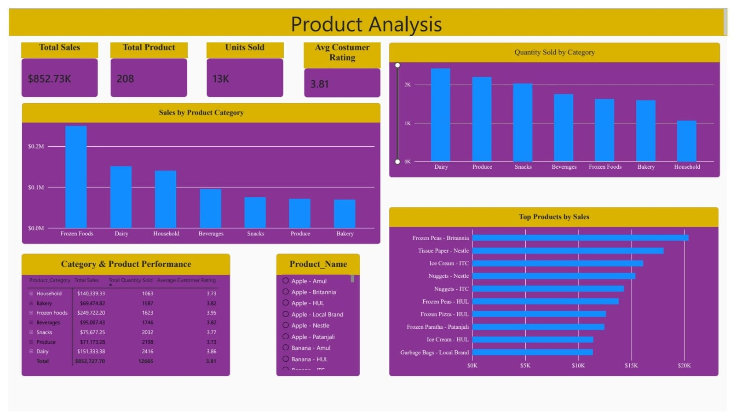
Figure 6.2: Product Analysis Dashboard

Analytical Purpose
- Identify high-performing products and categories.
- Compare sales contributions across products.
- Understand product demand using available sales data.
- Support product-level sales monitoring and inventory planning.

CHAPTER 6 — DASHBOARD DEVELOPMENT

6.3 Store and Employee Analysis Dashboard
The Store and Employee Analysis Dashboard examines sales performance across different stores and employees. It provides a structured view of sales contributions and supports comparisons between available store locations and employee records.
Visualizations help users identify differences in sales performance and understand how sales activity is distributed across stores and employees. These comparisons can highlight areas that may require further investigation.
The dashboard supports interactive exploration through filters and visual elements, allowing users to examine specific stores or employees.
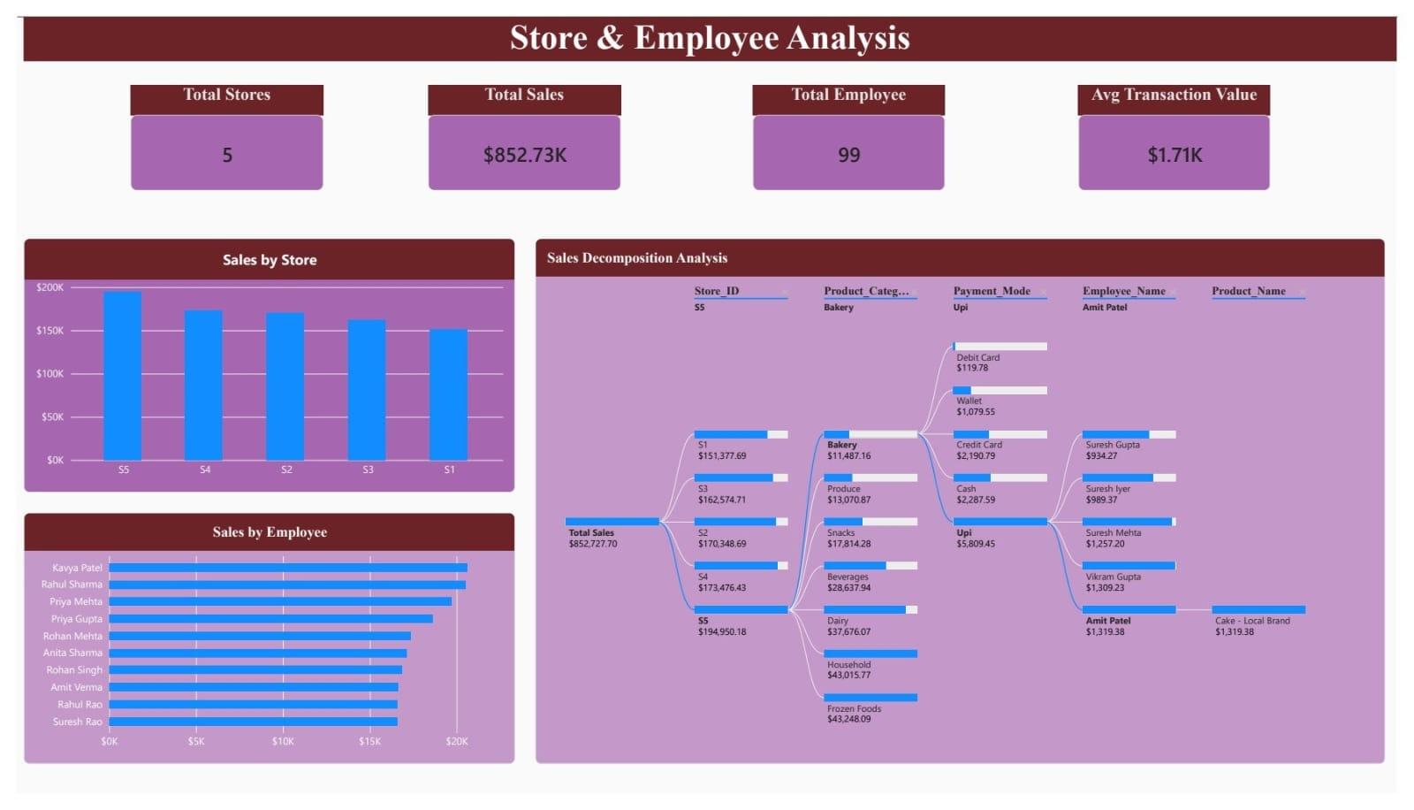
Figure 6.3: Store and Employee Analysis Dashboard

Analytical Purpose
- Compare sales performance across stores.
- Analyse employee-level sales contributions.
- Identify differences in sales activity.
- Support performance monitoring and operational planning.

CHAPTER 6 — DASHBOARD DEVELOPMENT

6.4 Sales and Discount Analysis Dashboard
The Sales and Discount Analysis Dashboard examines the relationship between sales performance and discount activity. It helps users review sales values alongside available discount information and understand how discount patterns vary across products and transactions.
The dashboard uses charts and analytical visuals to compare sales and discount data. These comparisons can help identify patterns that require further investigation and support the evaluation of discount practices.
The dashboard also allows users to apply filters to explore specific products, categories or periods, depending on the available report fields.
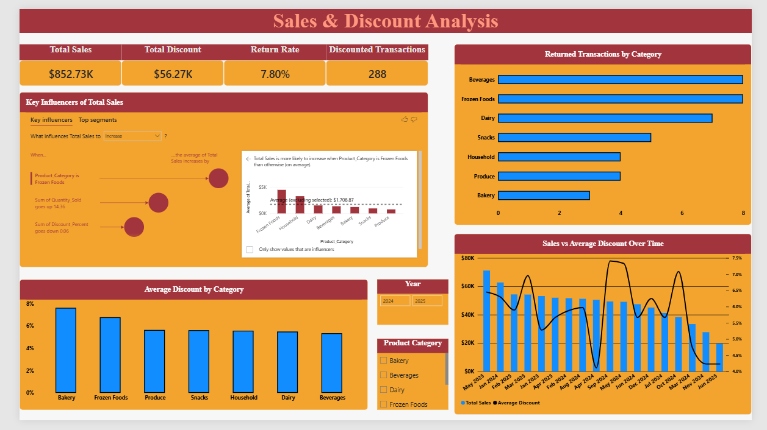
Figure 6.4: Sales and Discount Analysis Dashboard

Analytical Purpose
- Examine sales and discount patterns.
- Compare discount activity across available categories.
- Explore how sales values vary alongside discounts.
- Support the review of discount practices using historical data.

CHAPTER 6 — DASHBOARD DEVELOPMENT

6.5 Customer and Transaction Analysis Dashboard
The Customer and Transaction Analysis Dashboard focuses on customer-related information and transaction activity recorded in the grocery sales dataset. It provides an overview of available customer ratings, payment methods and transaction patterns.
The dashboard uses visualizations to present customer and transaction information in an organized format. This helps users explore purchasing activity and understand how transactions are distributed across available payment methods and other relevant categories.
Interactive filters allow users to investigate specific segments of the available data.
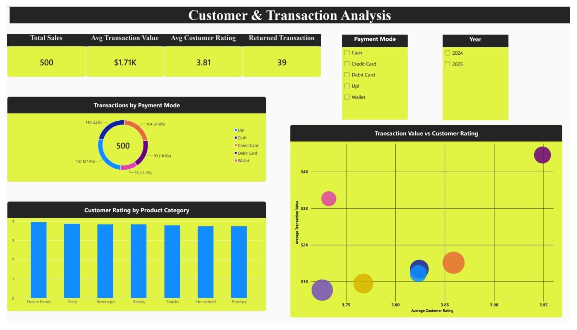
Figure 6.5: Customer and Transaction Analysis Dashboard

Analytical Purpose
- Examine transaction activity and payment methods.
- Analyse customer ratings recorded in the dataset.
- Explore purchasing patterns across available categories.
- Support customer experience and transaction analysis.

CHAPTER 6 — DASHBOARD DEVELOPMENT

6.6 Future Sales Predictions Dashboard
The Future Sales Predictions Dashboard focuses on examining historical sales patterns and exploring potential future sales trends. It uses the forecasting capabilities available in Power BI to present estimated sales values based on historical data.
The dashboard helps users observe changes in sales over time and understand the projected direction of sales activity. Forecast results should be interpreted as estimates rather than guaranteed outcomes, as future sales may be affected by changes in customer demand, pricing, discounts and other business conditions.
The historical trend and forecast visualization provides additional information for sales planning and helps users explore possible future performance.
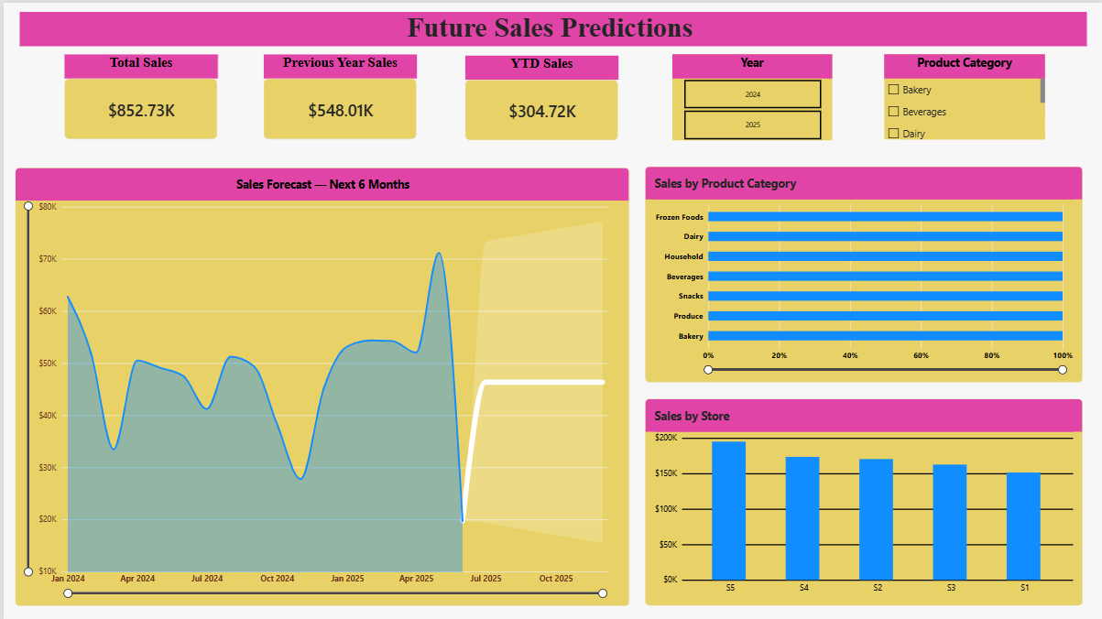
Figure 6.6: Future Sales Predictions Dashboard

Analytical Purpose
- Examine historical sales trends.
- Visualize projected future sales.
- Support preliminary sales planning.
- Understand the limitations of forecasting based on historical data.

CHAPTER 7 — ANALYTICAL FINDINGS

7.1 Overview of Findings
The six Power BI dashboards provide an integrated view of grocery sales performance across products, stores, employees, discounts, customer transactions, and future sales predictions. The analysis identifies important sales patterns and supports data-driven business decisions.

7.2 Major Analytical Areas
- Overall Sales Performance: Total sales reached $852,727.70 across 500 transactions, with approximately 12,665 units sold and an average transaction value of $1.71K.
- Product Performance: Frozen Foods generated the highest sales ($249,722.20), followed by Dairy ($151,333.38). Dairy recorded the highest quantity sold, with 2,416 units, while Bakery generated the lowest category sales ($69,474.82).
- Store and Employee Performance: Store S5 recorded the highest sales ($194,950.18), followed by S2 ($170,348.69). The dashboard also enables comparisons of sales contributions across employees.
- Discount and Return Analysis: Total discounts amounted to approximately $56.27K, with a displayed return rate of 7.80% and 288 discounted transactions. Category-wise return counts provide additional insight into transaction outcomes.
- Customer and Transaction Behaviour: The average customer rating was 3.81. UPI was the most frequently used payment method, accounting for 137 transactions (27.4%).
- Future Sales Trends: The forecasting dashboard presents projected sales for the next six months using historical data. These projections support preliminary planning but should be treated as estimates.

7.3 Interpretation of Findings
The results show that Frozen Foods was the leading category by sales value, whereas Dairy led in quantity sold. This difference demonstrates why revenue and product demand should be evaluated separately. Store S5 contributed the highest sales among the five stores, while payment analysis identified UPI as the leading transaction method. Discount and return indicators provide additional information for reviewing sales activity. The forecasting dashboard supports the examination of possible future trends, although actual results may differ from predictions.

7.4 Profitability Limitation
Sales performance should not be confused with profitability. Products or stores generating higher revenue are not necessarily more profitable because product costs and operating expenses are unavailable in the dataset. Therefore, the findings describe sales and transaction performance rather than profit.

CHAPTER 8 — BUSINESS RECOMMENDATIONS

8.1 Recommendations for Sales Management
The Power BI report provides an interactive view of grocery sales performance. The following recommendations can help use the available insights for retail decision-making.
1. Monitor Sales Performance: Review key performance indicators regularly to identify changes in sales activity and transaction values.
2. Review Product Demand: Use product-level comparisons to identify items with higher sales contributions and support inventory planning.
3. Evaluate Store Performance: Compare sales activity across stores to identify differences and investigate possible reasons for variations.
4. Assess Employee Performance: Review employee-level sales information to understand sales contributions and identify areas where additional support may be useful.
5. Review Discount Practices: Examine discount patterns alongside sales values to support informed decisions about promotional activities. Sales increases alone should not be treated as evidence of higher profitability.
6. Improve Customer Experience: Review customer ratings and transaction information to identify areas that may require further investigation.
7. Use Forecasts Carefully: Consider projected sales trends as planning estimates and update decisions as new transaction data becomes available.

8.2 Expected Benefits
Implementing these recommendations can support more structured sales monitoring, product planning, store comparisons and customer-related analysis. Regular use of the dashboards can help decision-makers identify patterns and investigate changes using the available data.
The recommendations should be evaluated against actual business results. Since the dataset does not include product costs or operating expenses, profitability-related decisions require additional financial information.

CHAPTER 9 — TESTING AND VALIDATION

9.1 Introduction
Testing and validation are important steps in ensuring that the Grocery Sales Data Analysis report produces consistent and meaningful results. The Power BI report is reviewed to verify data preparation, table relationships, DAX calculations, visualizations and interactive filtering.

9.2 Testing Activities
The following checks are performed to evaluate the report:
Test Area | Validation Activity
Data Preparation | Check data types, missing values and data consistency
Table Relationships | Verify relationships between the Sales table and supporting tables
DAX Measures | Compare calculated results with the underlying data
KPI Cards | Confirm that displayed values match the corresponding measures
Visualizations | Check that charts represent the selected data correctly
Filters and Slicers | Verify that relevant visuals respond to selections
Date Analysis | Check sales calculations across selected dates and periods
Forecasting | Review the historical data and projected trend displayed in the forecast visual
Table 9.2: Testing Activities and Validation Procedures

9.3 Validation of Results
The report should be checked under different filter selections to confirm that the displayed results update as expected. Sales totals and other numerical measures should be compared with the source data or independently calculated values wherever possible.
Any incorrect relationships, unexpected totals or inconsistent visual responses should be investigated and corrected before the report is finalized.

9.4 Testing Outcome
The report was reviewed for consistency in displayed KPI values, data relationships, visualizations and interactive filters. The checks performed helped identify areas requiring correction and improve the reliability of the report. The results are limited to the validation activities completed during the project.

CHAPTER 10 — LIMITATIONS AND FUTURE SCOPE

10.1 Limitations
The Grocery Sales Data Analysis project provides useful insights into retail sales performance; however, certain limitations should be considered when interpreting the results.
- Limited Financial Information: The dataset does not include product costs or operating expenses. Therefore, profit margins and overall profitability cannot be calculated reliably.
- Historical Data Dependency: The analysis is based on the transactions available in the supplied dataset and may not represent future market conditions.
- Forecasting Uncertainty: Forecasted sales values are estimates based on historical patterns and may differ from actual future sales.
- Data Quality Dependency: Missing, inconsistent or inaccurate source records may affect the accuracy of calculations and visualizations.
- Scope of Analysis: The report is limited to the fields available in the dataset and cannot evaluate business factors that are not recorded.

10.2 Future Scope
The project can be extended by incorporating additional data and analytical capabilities.
- Profitability Analysis: Include product costs and operating expenses to calculate profit and profit margins.
- Inventory Analysis: Integrate stock levels, reorder points and inventory movement to support stock management.
- Advanced Forecasting: Evaluate additional forecasting methods and compare their accuracy against actual sales.
- Customer Segmentation: Include suitable customer attributes and purchasing history to identify customer groups.
- Automated Reporting: Schedule data refreshes and report distribution where supported by the available Power BI environment.
- Expanded Data Integration: Combine sales data with additional business information to enable broader retail analysis.
These improvements could increase the analytical depth of the report and provide a stronger foundation for retail decision-making.

CHAPTER 11 — CONCLUSION
The Grocery Sales Data Analysis project demonstrates the practical application of Business Intelligence techniques using Microsoft Power BI. The project transforms grocery sales data into an organized analytical report through data preparation, relationship modelling, DAX calculations and interactive dashboard development.
The six dashboards provide different perspectives on sales performance, product demand, store and employee activity, discount patterns, customer transactions and future sales trends. Key performance indicators and interactive visualizations help present the available information in a clear and structured manner.
The project also demonstrates the importance of data quality, appropriate table relationships and accurate calculations in developing a reliable Business Intelligence solution. Historical analysis and forecasting provide additional support for understanding sales patterns and exploring potential future trends.
Although the report supports sales monitoring and data-driven analysis, its conclusions remain limited to the information available in the dataset. Profitability cannot be established without product costs and operating expenses, and forecasts should be interpreted as estimates rather than guaranteed outcomes.
Overall, this project provides practical experience in data analytics, Power BI, Power Query, DAX, data modelling and dashboard development. It demonstrates how Business Intelligence can help organize retail information, identify meaningful patterns and support informed business decisions.

REFERENCES

- Microsoft. Power BI Documentation — Power BI Desktop, Data Modelling, Visualizations and Report Design.
https://learn.microsoft.com/en-us/power-bi/

- Microsoft Learn. Data Analysis Expressions (DAX) Documentation and Function Reference.
https://learn.microsoft.com/en-us/dax/

- Microsoft Learn. Power Query Documentation — Data Transformation and Preparation.
https://learn.microsoft.com/en-us/power-query/

- Microsoft Learn. Power BI Data Modelling — Relationships and Data Transformation.
https://learn.microsoft.com/en-us/power-bi/transform-model/

- Microsoft Learn. Power BI Visualizations — Charts, Tables and Interactive Reports.
https://learn.microsoft.com/en-us/power-bi/visuals/power-bi-visualizations-overview

- Microsoft Learn. Power BI Desktop — Learn DAX Basics.
https://learn.microsoft.com/en-us/power-bi/transform-model/desktop-quickstart-learn-dax-basics

- Grocery Sales Dataset. Dataset supplied for the Grocery Sales Data Analysis project.
https://www.kaggle.com/datasets/arjunsinghgangwar/grocery-store-sales-dataset

APPENDIX A — KEY DAX MEASURES

A.1 Key Performance Indicator Measures

1. Total Sales: Total Sales = SUM(Sales[Final Sales])
2. Total Quantity Sold: Total Quantity Sold = SUM(Sales[Quantity_Sold])
3. Total Transactions: Total Transactions = DISTINCTCOUNT(Sales[Transaction ID])
4. Average Transaction Value: Average Transaction Value = DIVIDE([Total Sales], [Total Transactions])

A.2 Time-Based Measures

5. Year-to-Date Sales: YTD Sales = TOTALYTD([Total Sales], 'Date'[Date])
6. Previous Year Sales:
Previous Year Sales =
CALCULATE(
[Total Sales],
SAMEPERIODLASTYEAR('Date'[Date])
)

7. Year-over-Year Growth:
YoY Growth =
DIVIDE(
[Total Sales] - [Previous Year Sales],
[Previous Year Sales]
)

